Bamboo Installation
Applications
Bamboo Floor can be installed on concrete, tiles, existing timber floors, plywood or particle board as long as the floor is structurally sound, clean, level and dry. Bamboo Floor is recommended for internal use only, and should not be installed in wet areas like bathrooms or laundries or in external environments exposed to the elements. Bamboo Flooring is tongued and grooved and end matched and designed to be glued down or nailed down. The wide board can be floated on underlay.
Pre-Installation
Important: Please carefully inspect all material before installation.
Pre-finished Bamboo Flooring should only be installed in the final stages of completion of a construction project with all trades people having left the site. All work involving water or moisture should be completed prior to installation (cement work, plastering, painting, plumbing, and tiling etc). Should this not be the case, installation should be delayed to avoid damage to the coating of the Bamboo Flooring.
The building should be roofed and enclosed with the temperature and humidity as close as possible to in-service conditions including the use of air conditioning. Flooring should be delivered at least 2-3 days prior to installation and the boxes opened to allow the Bamboo Floor to adjust to normal room temperature and humidity. Avoid installing Bamboo Floor in very damp or humid conditions.Air conditioning should be running at least 2 days before and during installation.
Note: Bamboo Floor systems makes no warranty or guarantee of the quality of the chosen installer's work. Bamboo Floor Systems disclaims all liability for any errors or improprieties in the installation of its product by an installer.

Nail down glue Method over plywood or yellow tongue
***********************************************************
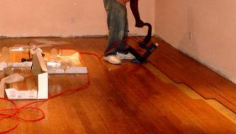
Flooring can be laid over plywood or yellow tongue sheeting. Flooring can be installed by using secret nailing with a finishing gun and gluing with construction adhesive. Always test your equipment and gauge size and air pressure on a few samples before laying the actual floor. Start rows should be held firmly in place by wedging, secret nailing or adhesive. Once start rows are secure, apply a bead of construction adhesive to the sub floor running 20-30cm apart running perpendicular to the laying direction of the boards. Lay the rows, additional rows should be secret nailed using a finishing gun directly above the Tongue at a 45 degree angle to the face. Fasteners should be spaced at 20-30cm intervals per plank.

Glue Down Method
****************************************************
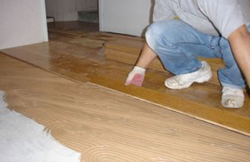
For glue down applications that are on or below grade (directly on concrete slab) a moisture barrier must be used.
Flooring is usually laid square with the space and parallel to its longest dimension. Place a 10mm spacer against the starting wall or skirting board. Using a 5mm notched trowel spread the adhesive evenly over the prepared surface. Only spread enough glue for 3 or 4 board widths at a time. From the starting wall, place the groove first and lay each board carefully and firmly and secure into position by nailing a 25mm small nail into the tongue at a 45 degree angle every 200mm. Place each tongue firmly into the corresponding groove of the next board. Bamboo flooring is laid in a brick pattern. Do not nail within 30mm from the end of the board as this might split the bamboo. Check every 4-5 boards to ensure that you are square to the starting wall. It is a good idea to mark a line on your underlay or sub-floor to line up the joins. Where you are not nailing boards and are direct sticking to sub floor make sure the floor is adequately weighted. Continue this process until the floor is complete. Remember to leave a 10mm gap at each wall surface or edge over a 8m span. Any greater spans will require an expansion strip to be placed in the middle of the floor. Do not walk on floor for at least 24 hours to allow adhesive to set.
Important: Do not allow glue to penetrate through the tongue in/on to the surface. If this occurs, then wipe off immediately with a turps or methylated spirits covered rag.
Floating Installation
***************************************
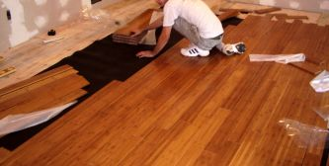
Important: Only wide board may be floated. Moisture protection is required over any subfloor when floating the floor.
If required, remove any skirting, quarter round or doorway thresholds that may be in place. Doorway architraves should be undercut to allow the flooring to fit neatly when installed. This is best done using a hand saw. A piece of underlay and flooring placed against the architrave will act as a guide for height. Unroll the underlay so that all ends and sides fit neatly against the wall. Seams between lengths should also butt together so that no overlap occurs. Tape all ends, sides and seams with waterproof tape to ensure the water vapour barrier properties of the underlay are maintained. The underlay should be laid at 90 degrees to the intended direction of the flooring.
Start planks square with the room and parallel to the longest dimension but leaving 10-15mm expansion space from the wall. Cork spacers approximately 600mm apart or near the plank ends should be left between the floor boards and the wall structure. Place the groove to the wall. Apply a thin line of adhesive to the top inside edge of the next groove in a continuous line and insert into the plank's tongue using a tapping block and tap until the boards are firmly together. When starting the second row, we suggest the first board be a minimum of 600mm shorter than the original board to achieve a brick or random pattern. The last row will probably need to be cut to the required width. A small crow bar can be used to gain leverage against the wall when trying to ease the last of the boards together. Straps may be required while the glue is drying to hold boards together. Remove any excess adhesive immediately with a damp cloth and wipe dry to avoid "smearing". Remember to seal any cut edges of the Bamboo Flooring.

